SmartAgri Wokwi Simulation Test Cases
  - Supplementary evidence for the SmartAgri research paper
Rishit Chaudhary 23BCT0157 and Siddharth Verma 23BCT0159
This supplement preserves the complete circuit-and-Serial screenshots for the 18 Wokwi functional cases, two additional firmware views and the browser simulation evidence. It supports the concise research paper without treating screenshots as independent field trials.
Wokwi project: https://wokwi.com/projects/478323582523545601
Repository: https://github.com/rizzit17/SmartAgri

Evidence scope
The ESP32 runs Arduino/C++ against Wokwi DHT22 and potentiometer models. GPIO2 and an LED represent logical pump output. One commanded minute equals 1000 simulator milliseconds. Browser inputs are prescribed software traces; its transport outage is an in-process surrogate. Wokwi MQTT receipts are actual synthetic-data broker observations. Neither experiment measures water delivery, crop yield, physical sensor accuracy or field reliability.
The 18 case IDs refer to one firmware session with per-case resets; later framing repeats are counted once. Pausing during an OLED refresh can produce a dithered display. Read the recorded Serial values and GPIO state. The supplementary browser case labels refer to a separate experiment.

How to reproduce
Open the Wokwi project and click Start Simulation. To recreate it, paste wokwi/sketch.ino, controller.h, diagram.json and libraries.txt into matching files. Enter the commands shown on each case page one at a time into Serial Monitor, pressing Enter after each. Wait for a complete report; STATUS reports the existing state and does not sample again. CASE resets the filter and pending dose; STEP preserves them. Follow docs/wokwi-evidence/README.md for complete timing instructions and optional Python MQTT collection.

S-W01 Normal initial command
Conditions: M=50%, T=27 C, RH=60%. Commands: CASE 1.
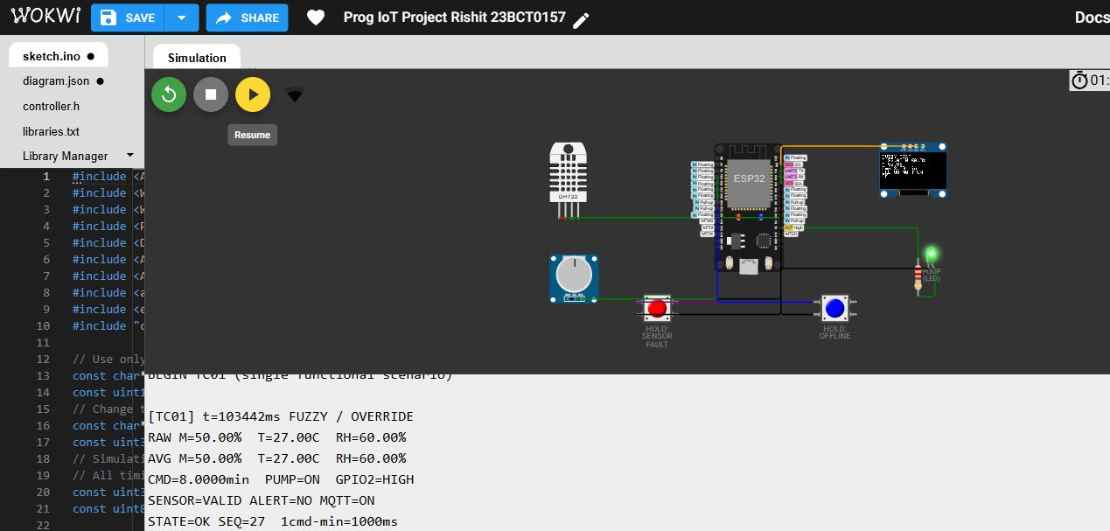
Observed: Normal fuzzy command: 8 min; pump ON/HIGH during dose. Command 8 min; output ON/GPIO2 HIGH; sensor VALID; alert NO; MQTT ON. Functional result: PASS.
Source: docs/wokwi-evidence/serial/TC01-normal-initial-command.txt; device uptime 103442 ms. Synthetic inputs and accelerated output timer.

S-W02 Wet soil no dose
Conditions: M=85%, T=27 C, RH=60%. Commands: CASE 2.
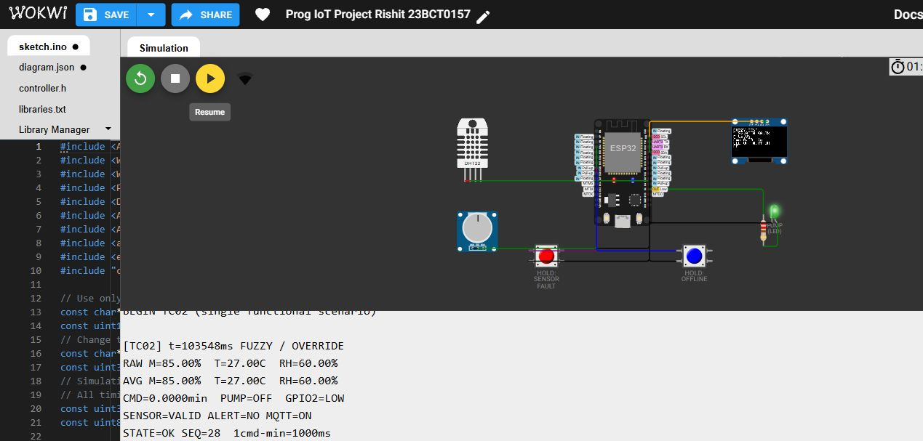
Observed: Wet soil: zero command; pump OFF/LOW. Command 0 min; output OFF/GPIO2 LOW; sensor VALID; alert NO; MQTT ON. Functional result: PASS.
Source: docs/wokwi-evidence/serial/TC02-wet-soil-no-dose.txt; device uptime 103548 ms. Synthetic inputs and accelerated output timer.

S-W03 Hot dry maximum command
Conditions: M=10%, T=45 C, RH=20%. Commands: CASE 3.
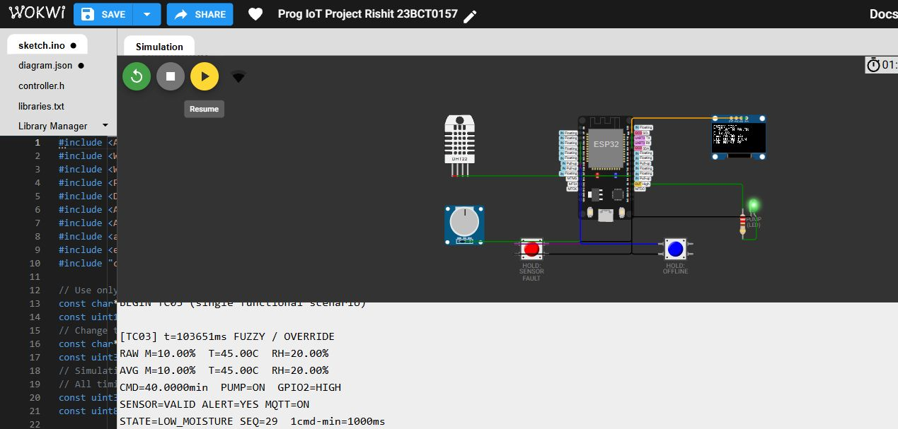
Observed: Hot, dry soil: maximum 40 min command; alert and pump ON. Command 40 min; output ON/GPIO2 HIGH; sensor VALID; alert YES; MQTT ON. Functional result: PASS.
Source: docs/wokwi-evidence/serial/TC03-hot-dry-maximum-command.txt; device uptime 103651 ms. Synthetic inputs and accelerated output timer.

S-W04 Inclusive alert at thirty percent
Conditions: M=30%, T=27 C, RH=60%. Commands: CASE 4.
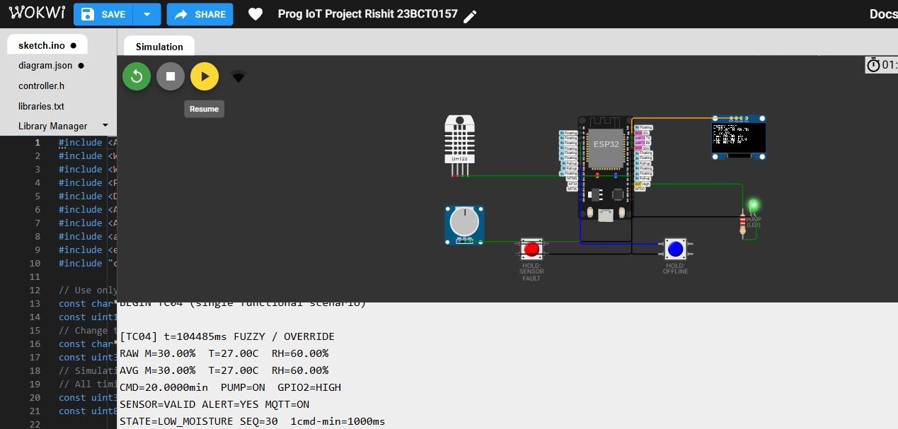
Observed: Inclusive low-moisture alert boundary: alert YES; command 20 min. Command 20 min; output ON/GPIO2 HIGH; sensor VALID; alert YES; MQTT ON. Functional result: PASS.
Source: docs/wokwi-evidence/serial/TC04-inclusive-alert-at-thirty-percent.txt; device uptime 104485 ms. Synthetic inputs and accelerated output timer.

S-W05 Above threshold at thirty one percent
Conditions: M=31%, T=27 C, RH=60%. Commands: CASE 5.
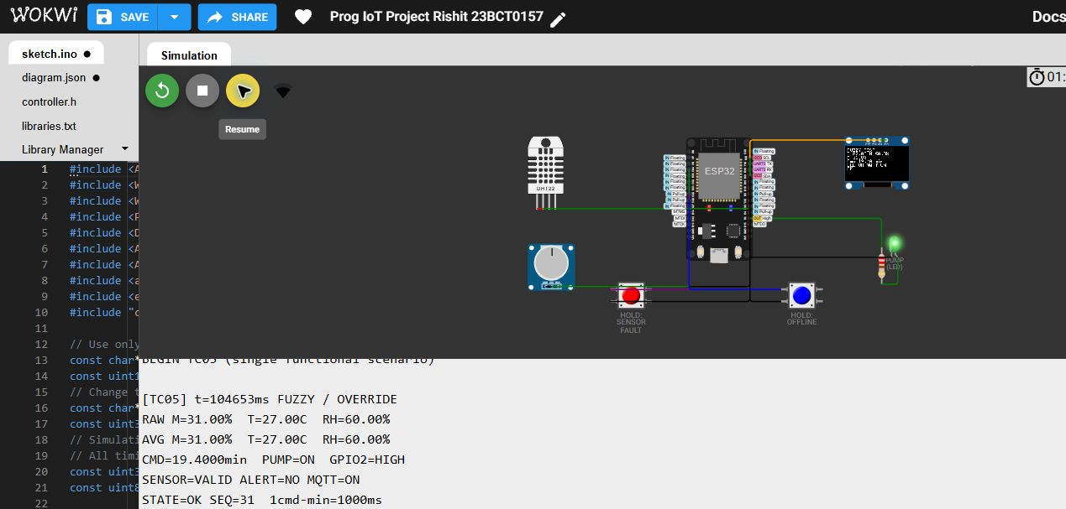
Observed: Above alert boundary: alert NO; command 19.4 min. Command 19.4 min; output ON/GPIO2 HIGH; sensor VALID; alert NO; MQTT ON. Functional result: PASS.
Source: docs/wokwi-evidence/serial/TC05-above-threshold-at-thirty-one-percent.txt; device uptime 104653 ms. Synthetic inputs and accelerated output timer.

S-W06 Cold dry rule coverage
Conditions: M=10%, T=10 C, RH=20%. Commands: CASE 6.
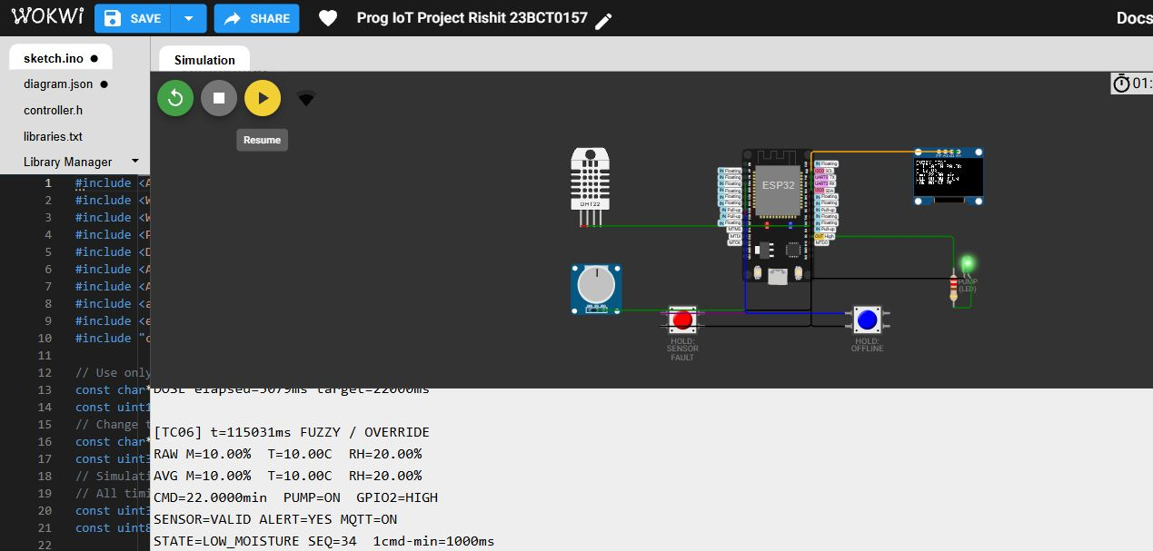
Observed: Cold, dry soil remains covered: command 22 min. Command 22 min; output ON/GPIO2 HIGH; sensor VALID; alert YES; MQTT ON. Functional result: PASS.
Source: docs/wokwi-evidence/serial/TC06-cold-dry-rule-coverage.txt; device uptime 115031 ms. Synthetic inputs and accelerated output timer.

S-W07 Valid minimum domain endpoint
Conditions: M=0%, T=0 C, RH=0%. Commands: CASE 7.
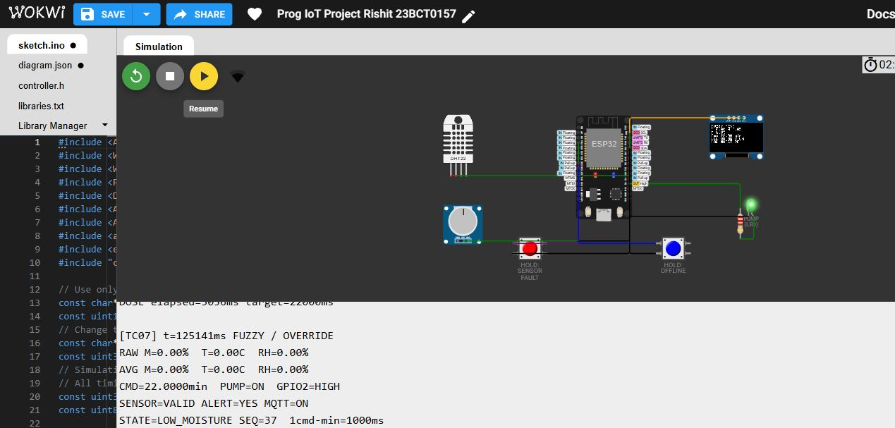
Observed: Lower valid domain endpoint: command 22 min; valid sensor state. Command 22 min; output ON/GPIO2 HIGH; sensor VALID; alert YES; MQTT ON. Functional result: PASS.
Source: docs/wokwi-evidence/serial/TC07-valid-minimum-domain-endpoint.txt; device uptime 125141 ms. Synthetic inputs and accelerated output timer.

S-W08 Valid maximum domain endpoint
Conditions: M=100%, T=50 C, RH=100%. Commands: CASE 8.
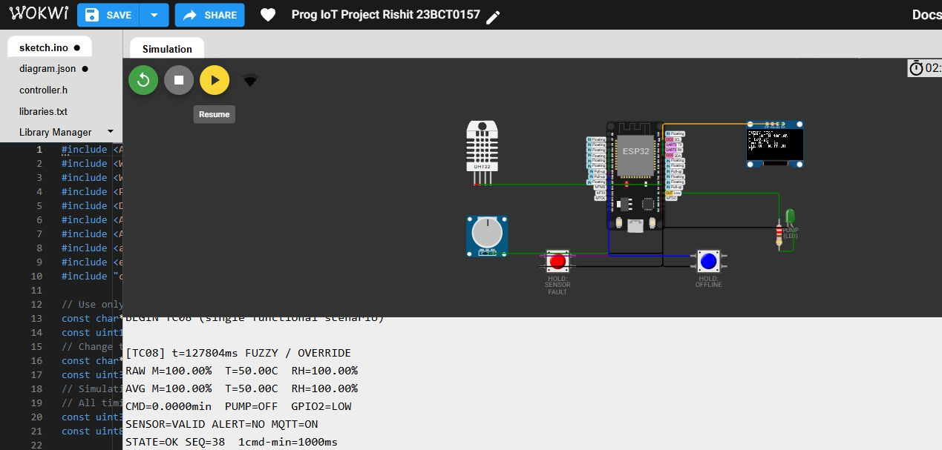
Observed: Upper valid endpoint: command zero; pump OFF. Command 0 min; output OFF/GPIO2 LOW; sensor VALID; alert NO; MQTT ON. Functional result: PASS.
Source: docs/wokwi-evidence/serial/TC08-valid-maximum-domain-endpoint.txt; device uptime 127804 ms. Synthetic inputs and accelerated output timer.

S-W09 Fault during active dose stops gpio
Conditions: Start at 10%,45 C,20%. Commands: CASE 9; then FAULT ON while pump is ON.
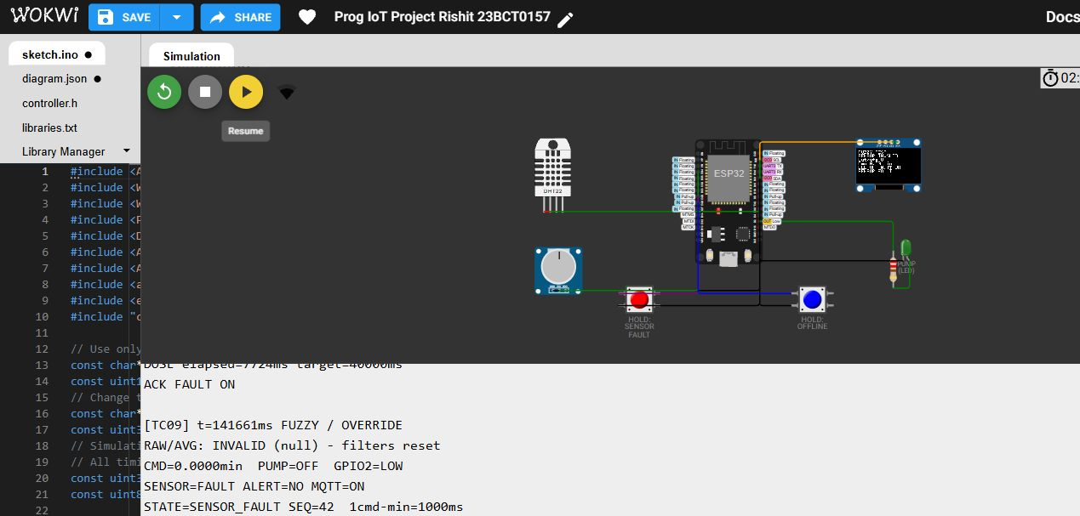
Observed: Injected sensor fault stops the active pump; sensor FAULT; command zero. Command 0 min; output OFF/GPIO2 LOW; sensor FAULT; alert NO; MQTT ON. Functional result: PASS.
Source: docs/wokwi-evidence/serial/TC09-fault-during-active-dose-stops-gpio.txt; device uptime 141661 ms. Synthetic inputs and accelerated output timer.

S-W10 Valid recovery resets filter
Conditions: M=50%, T=27 C, RH=60%. Commands: CASE 10.
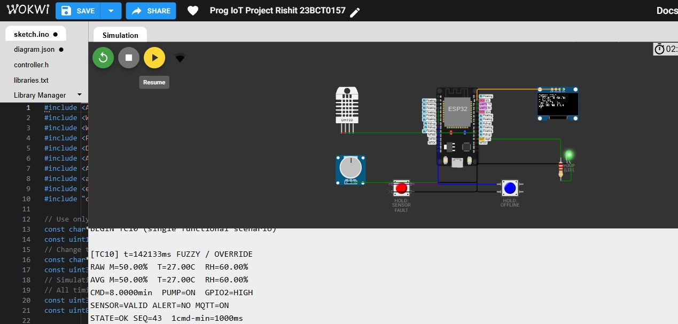
Observed: Recovery clears injected fault and produces valid 8 min command. Command 8 min; output ON/GPIO2 HIGH; sensor VALID; alert NO; MQTT ON. Functional result: PASS.
Source: docs/wokwi-evidence/serial/TC10-valid-recovery-resets-filter.txt; device uptime 142133 ms. Synthetic inputs and accelerated output timer.

S-W11 Offline timer completes without broker
Conditions: M=50%, T=27 C, RH=60%; networking disabled. Commands: CASE 11; wait >8 simulator seconds.
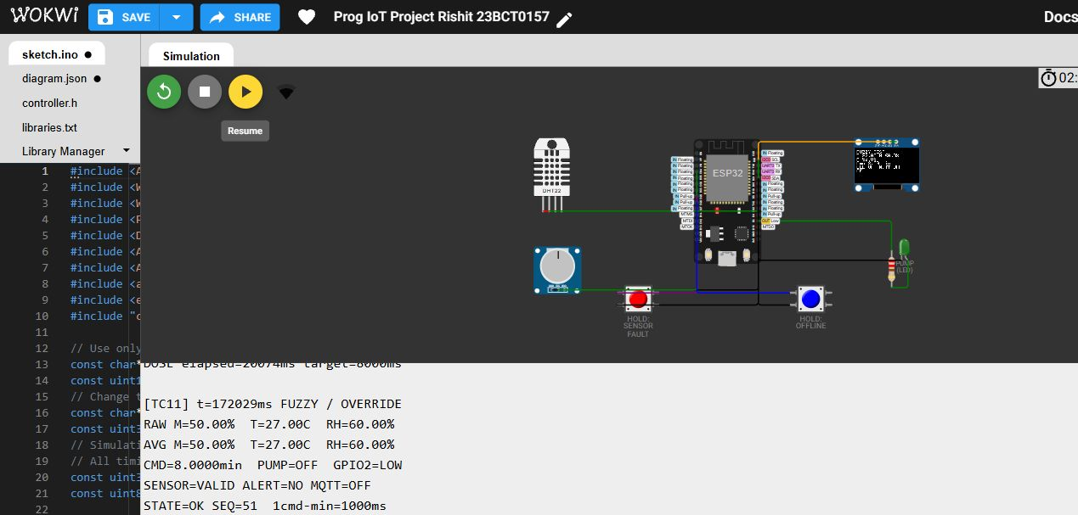
Observed: Local 8-second accelerated dose completes while MQTT is OFF. Command 8 min; output OFF/GPIO2 LOW; sensor VALID; alert NO; MQTT OFF. Functional result: PASS.
Source: docs/wokwi-evidence/serial/TC11-offline-timer-completes-without-broker.txt; device uptime 172029 ms. Synthetic inputs and accelerated output timer.

S-W12 Mqtt reconnect and receiver resumes
Conditions: M=50%, T=27 C, RH=60%; networking enabled. Commands: CASE 12; wait for MQTT=ON.
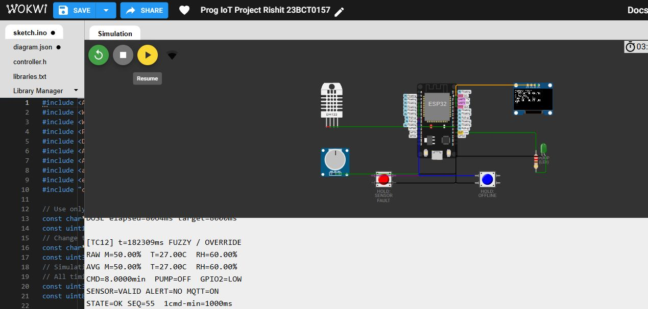
Observed: Broker reconnects; receiver resumes receiving snapshots. Command 8 min; output OFF/GPIO2 LOW; sensor VALID; alert NO; MQTT ON. Functional result: PASS.
Source: docs/wokwi-evidence/serial/TC12-mqtt-reconnect-and-receiver-resumes.txt; device uptime 182309 ms. Synthetic inputs and accelerated output timer.

S-W13 Baseline below thirty percent
Conditions: Baseline policy; M=29%, T=27 C, RH=60%. Commands: CASE 13.
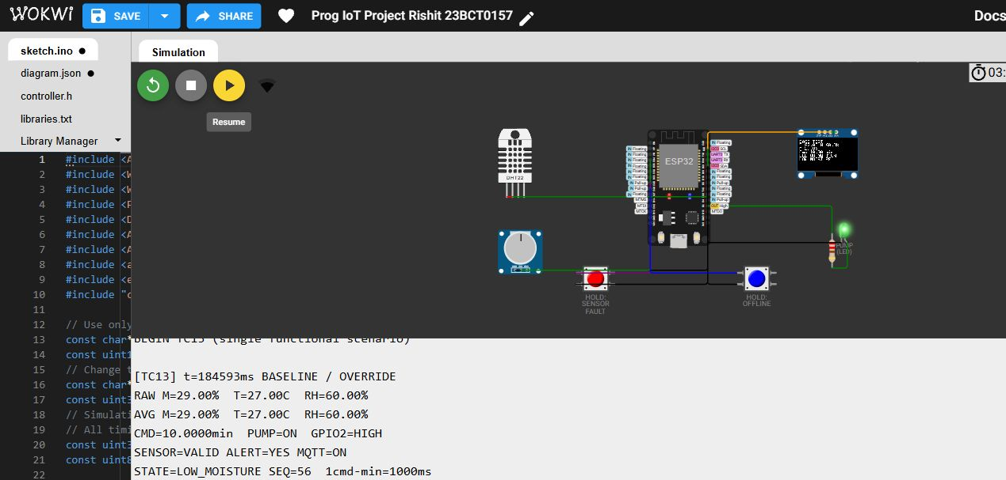
Observed: Threshold reference turns pump ON with 10 min command below 30%. Command 10 min; output ON/GPIO2 HIGH; sensor VALID; alert YES; MQTT ON. Functional result: PASS.
Source: docs/wokwi-evidence/serial/TC13-baseline-below-thirty-percent.txt; device uptime 184593 ms. Synthetic inputs and accelerated output timer.

S-W14 Baseline strict boundary at thirty
Conditions: Baseline policy; M=30%, T=27 C, RH=60%. Commands: CASE 14.
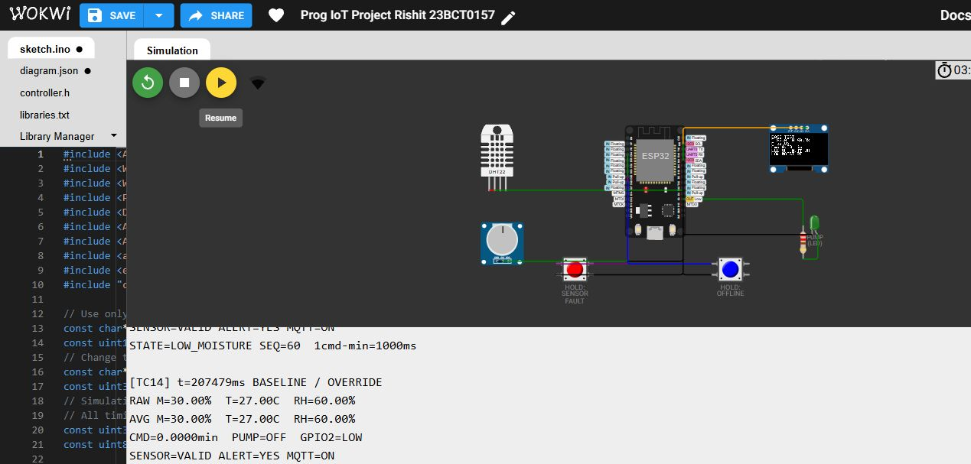
Observed: Reference pump OFF at exactly 30%; alert remains YES (alert uses <=30). Command 0 min; output OFF/GPIO2 LOW; sensor VALID; alert YES; MQTT ON. Functional result: PASS.
Source: docs/wokwi-evidence/serial/TC14-baseline-strict-boundary-at-thirty.txt; device uptime 207479 ms. Synthetic inputs and accelerated output timer.

S-W15 Timer expiry no repeated sample restart
Conditions: M=50%, T=27 C, RH=60%. Commands: CASE 15; wait >8 and <60 simulator seconds.
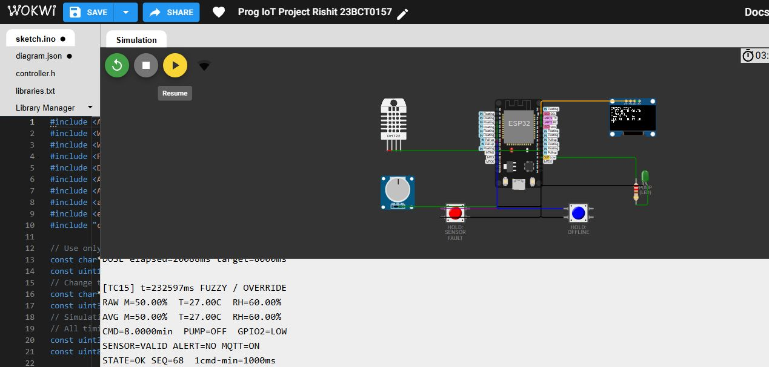
Observed: 8-second dose expires; subsequent 5-second samples do not restart it. Command 8 min; output OFF/GPIO2 LOW; sensor VALID; alert NO; MQTT ON. Functional result: PASS.
Source: docs/wokwi-evidence/serial/TC15-timer-expiry-no-repeated-sample-restar.txt; device uptime 232597 ms. Synthetic inputs and accelerated output timer.

S-W16 Out of range input rejected
Conditions: Start at M=50%, T=27 C, RH=60%. Commands: CASE 16; SET 101 27 60; STATUS.
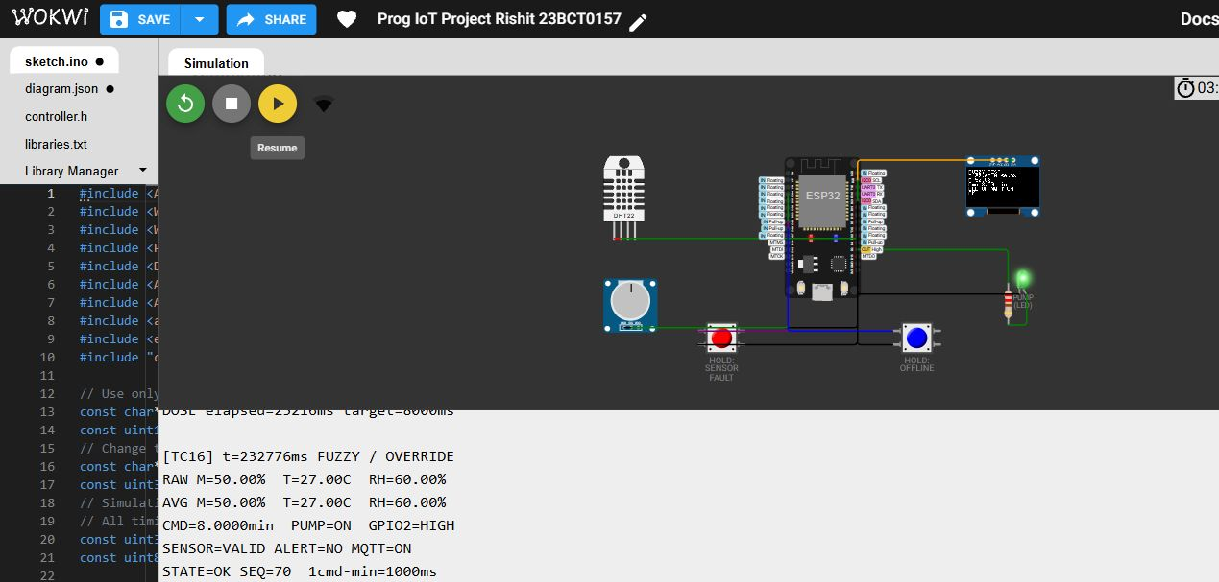
Observed: Out-of-domain SET is rejected; previous valid input and command remain. Command 8 min; output ON/GPIO2 HIGH; sensor VALID; alert NO; MQTT ON. Functional result: PASS.
Source: docs/wokwi-evidence/serial/TC16-out-of-range-input-rejected.txt; device uptime 232776 ms. Synthetic inputs and accelerated output timer.

S-W17 Raw wet step stops active dose
Conditions: Initial M=10%, T=45 C, RH=20%. Commands: CASE 17; STEP 90 45 20 while pump is ON.
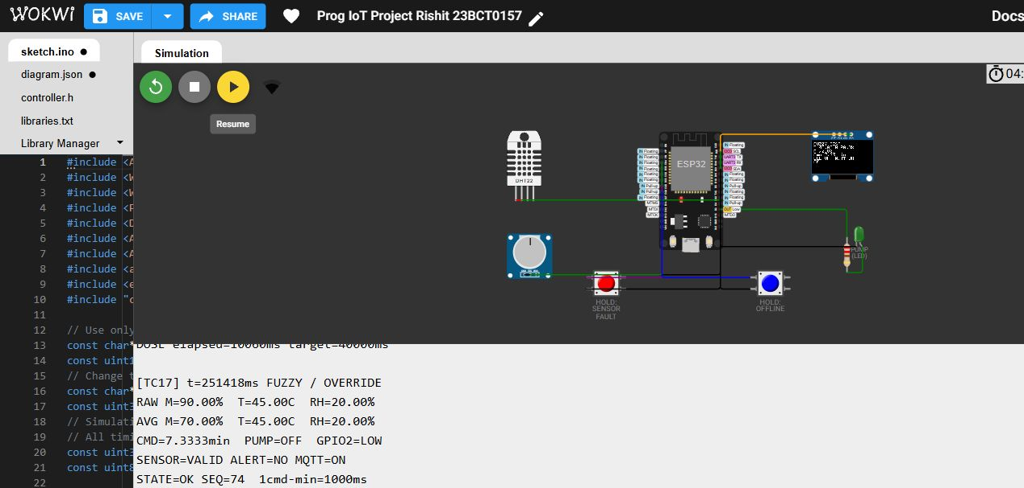
Observed: Raw wet reading stops output even while filtered moisture remains below 80%. Command 7.3333 min; output OFF/GPIO2 LOW; sensor VALID; alert NO; MQTT ON. Functional result: PASS.
Source: docs/wokwi-evidence/serial/TC17-raw-wet-step-stops-active-dose.txt; device uptime 251418 ms. Synthetic inputs and accelerated output timer.

S-W18 Filter settles after five samples
Conditions: Initial M=100%, T=27 C, RH=60%. Commands: CASE 18; wait >=5 samples; STEP 0 27 60.
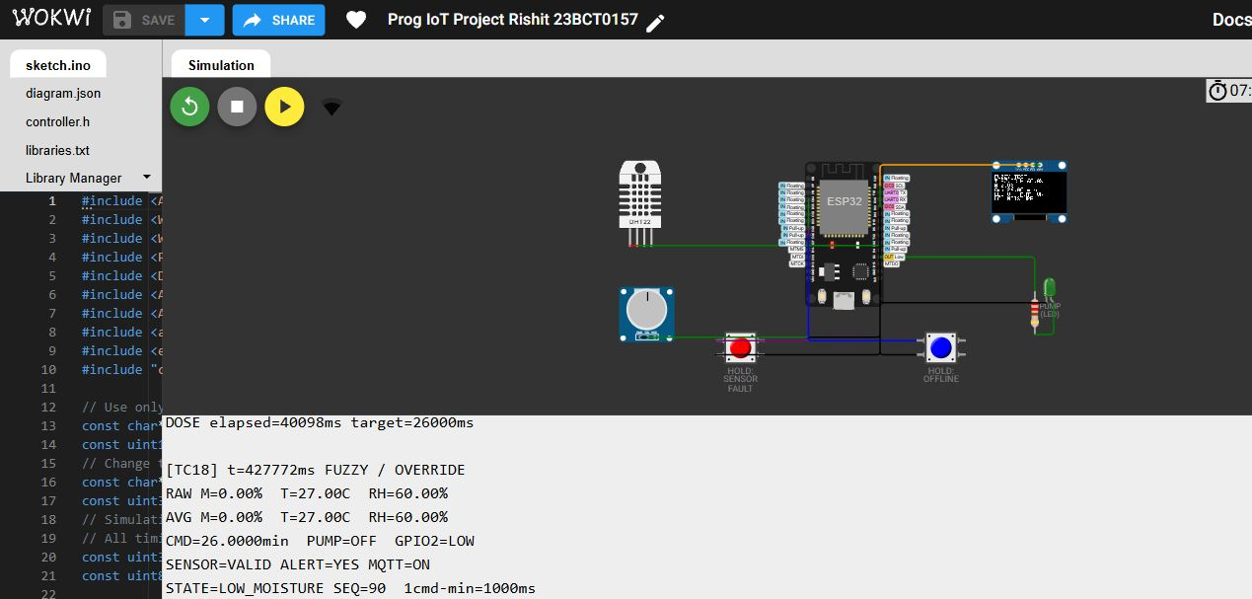
Observed: Five-sample response: 80, 60, 40, 20, 0%; settled command 26 min. Pump remains OFF until a new dose window. Command 26 min; output OFF/GPIO2 LOW; sensor VALID; alert YES; MQTT ON. Functional result: PASS.
Source: docs/wokwi-evidence/serial/TC18-filter-settles-after-five-samples.txt; device uptime 427772 ms. Synthetic inputs and accelerated output timer.

S-W19 Intermediate five-sample filter response
CASE 18; fill the window at 100%, then STEP 0 27 60.
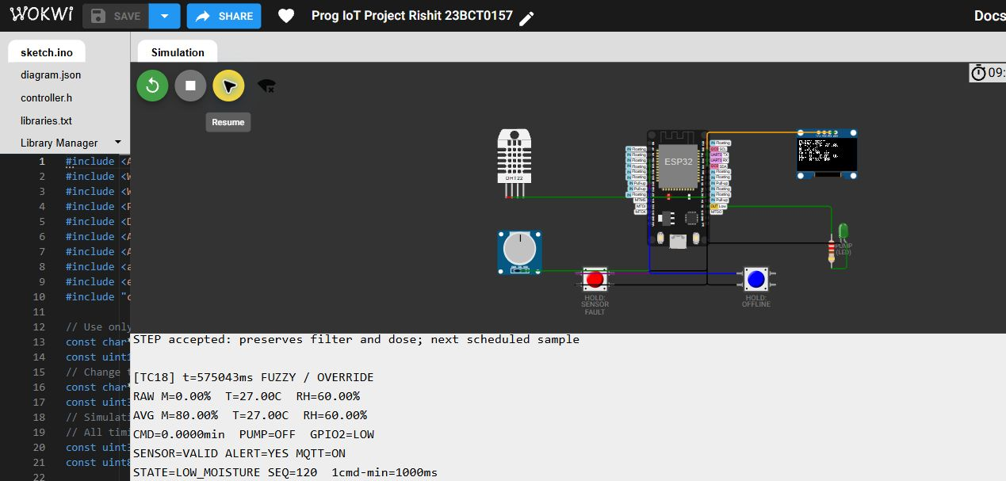
Raw moisture is 0% and the initial five-sample average is 80%. Subsequent averages are 60, 40, 20 and 0%. This framing repeat belongs to S-W18 and is not an additional independent case.
Source: docs/wokwi-evidence/serial/TC18-filter-intermediate.txt.

S-W20 LIVE virtual component readings
LIVE input source: Wokwi DHT22 and potentiometer.
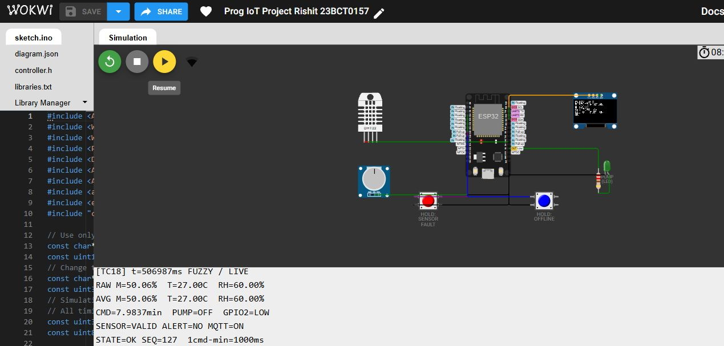
The virtual components report 27 C, 60% RH and approximately 50.06% moisture; command 7.9837 min. Output is OFF after its accelerated dose. The preceding TC18 label persists; FUZZY / LIVE identifies the input source. These are virtual measurements.
Source: docs/wokwi-evidence/serial/HW01-live-model-inputs.txt. Not an additional independent field trial.

S-B01 Browser simulation evidence
Separate Python/browser experiment with synthetic inputs and accelerated timers.
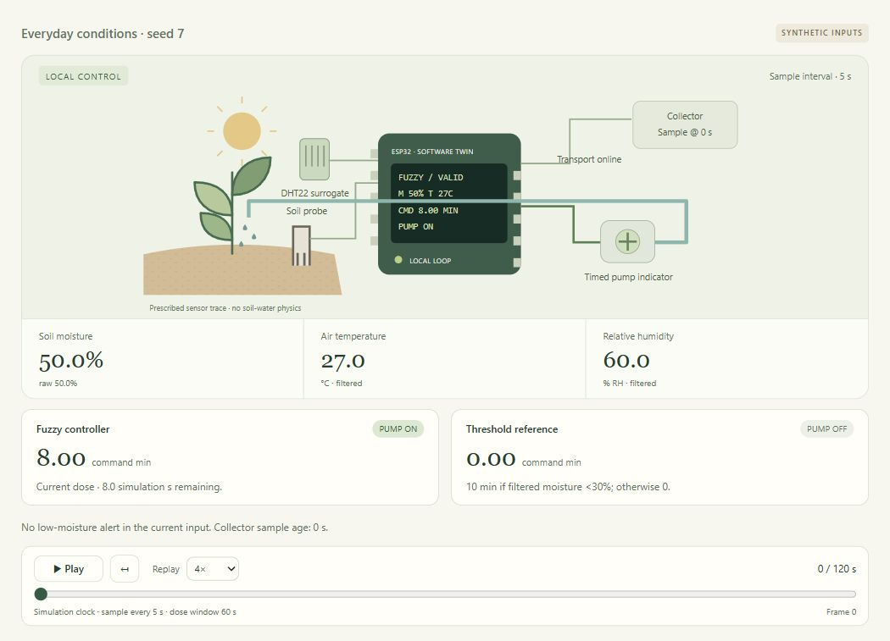
Normal synthetic input at 50% moisture, 27 °C and 60% RH produces an 8-minute fuzzy command and zero reference command.
Replay context: 0 / 120 s. Saved run: 20261024T190126038644Z-870a58f4. Raw trace and settings accompany the paper.

S-B02 Browser simulation evidence
Separate Python/browser experiment with synthetic inputs and accelerated timers.
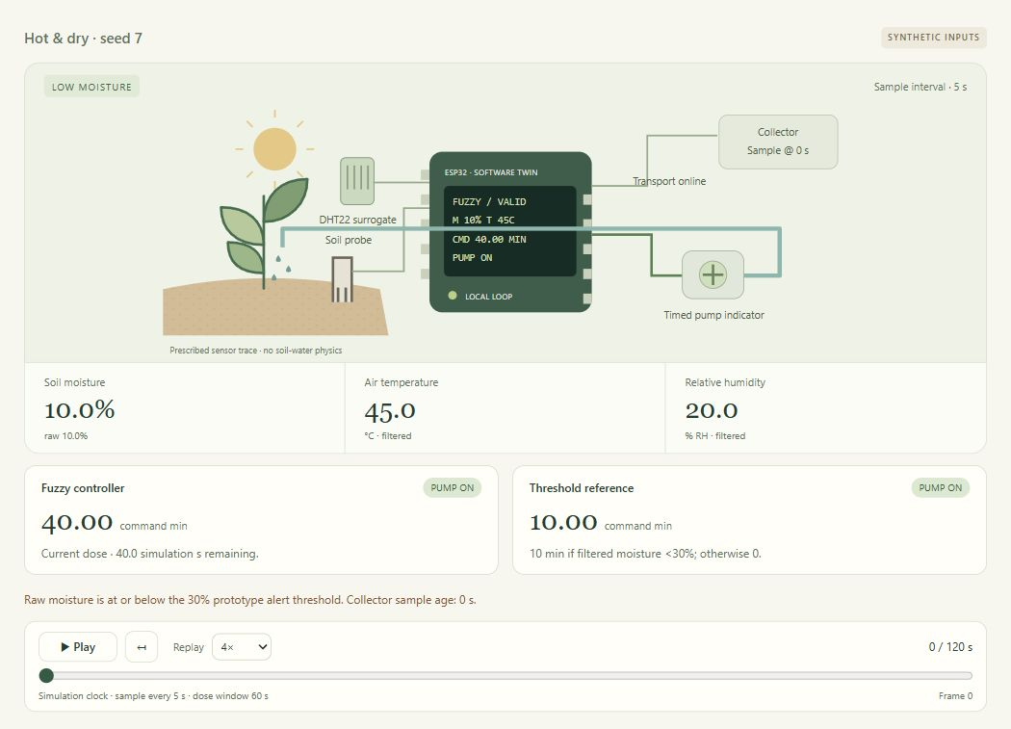
Dry and hot synthetic inputs produce a 40-minute fuzzy command and a 10-minute threshold-reference command.
Replay context: 0 / 120 s. Saved run: 20261024T190206689673Z-9a66375e. Raw trace and settings accompany the paper.

S-B03 Browser simulation evidence
Separate Python/browser experiment with synthetic inputs and accelerated timers.
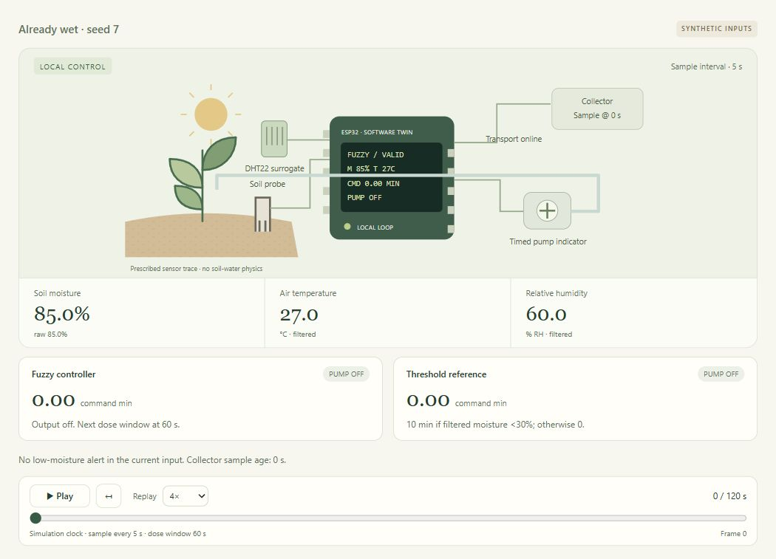
At 85% moisture both controllers issue zero and both logical pump outputs remain off.
Replay context: 0 / 120 s. Saved run: 20261024T190209514836Z-3f3b5a77. Raw trace and settings accompany the paper.

S-B04 Browser simulation evidence
Separate Python/browser experiment with synthetic inputs and accelerated timers.
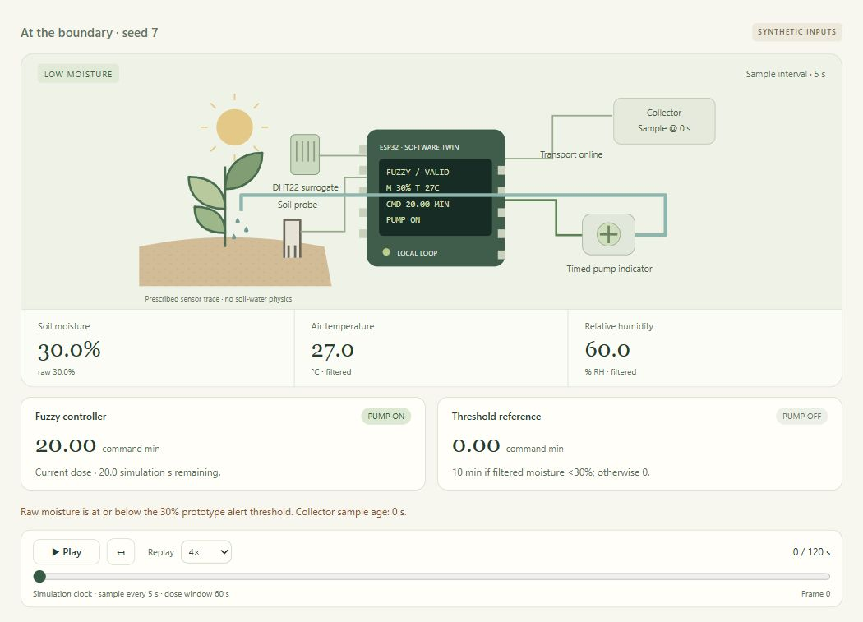
At exactly 30% moisture the inclusive low-moisture alert is active; the fuzzy command is 20 minutes while the strict threshold reference is zero.
Replay context: 0 / 120 s. Saved run: 20261024T190212418524Z-d9cae169. Raw trace and settings accompany the paper.

S-B05 Browser simulation evidence
Separate Python/browser experiment with synthetic inputs and accelerated timers.
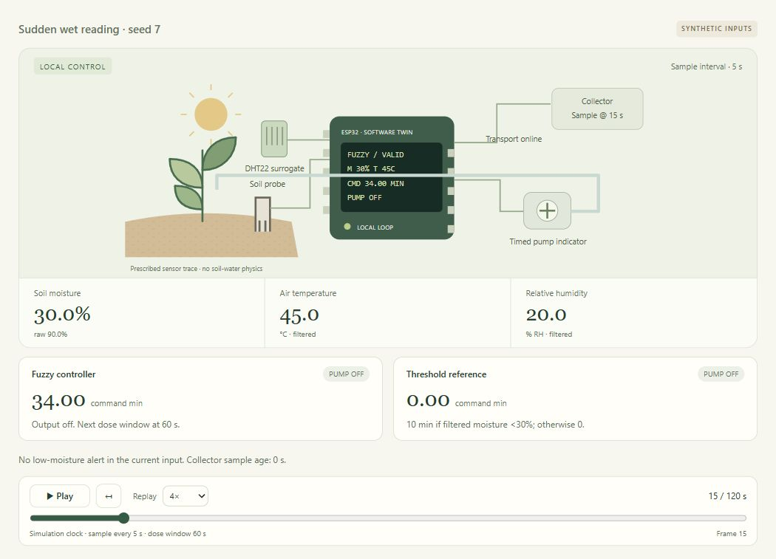
At 15 s raw moisture rises to 90%, while the moving average is 30%. The safety gate stops the pump despite a nonzero 34-minute fuzzy command.
Replay context: 15 / 120 s. Saved run: 20261024T190224597554Z-1e1fe932. Raw trace and settings accompany the paper.

S-B06 Browser simulation evidence
Separate Python/browser experiment with synthetic inputs and accelerated timers.
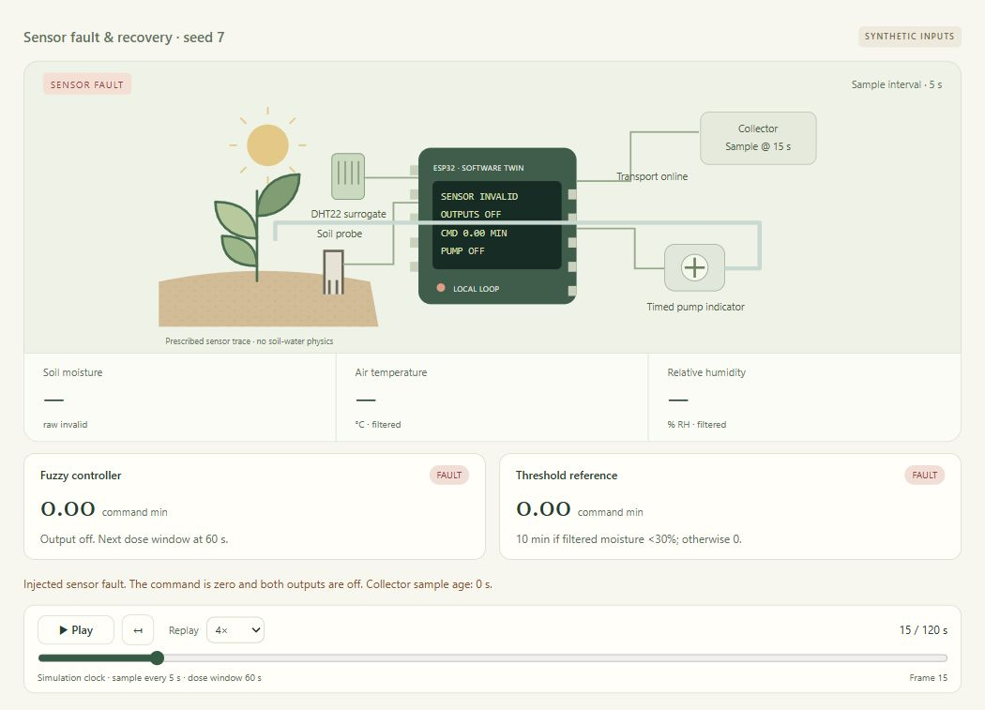
An injected fault produces unavailable sensor values, zero commands and both outputs off at 15 s.
Replay context: 15 / 120 s. Saved run: 20261024T190227823951Z-410c5b7b. Raw trace and settings accompany the paper.

S-B07 Browser simulation evidence
Separate Python/browser experiment with synthetic inputs and accelerated timers.
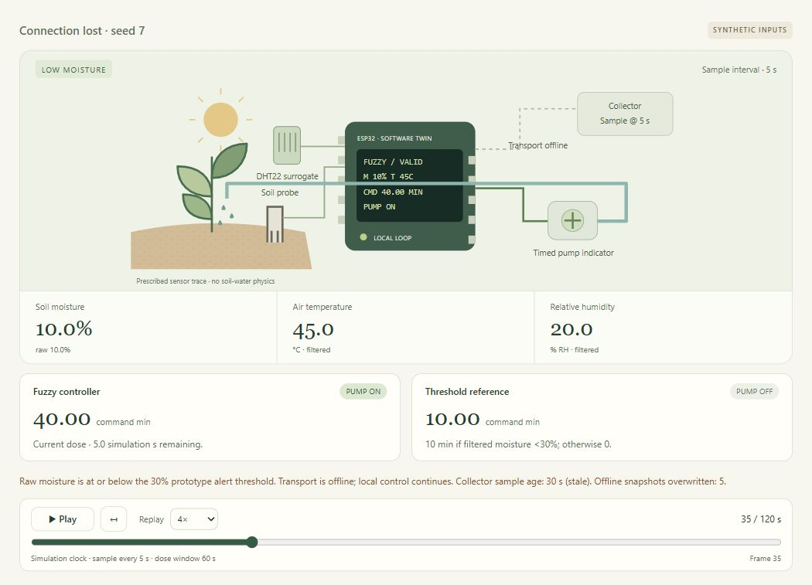
During the 10–40 s transport outage, local control remains active at 35 s while the collector holds its stale 5 s snapshot.
Replay context: 35 / 120 s. Saved run: 20261024T190230939923Z-d75c0339. Raw trace and settings accompany the paper.

S-B08 Browser simulation evidence
Separate Python/browser experiment with synthetic inputs and accelerated timers.
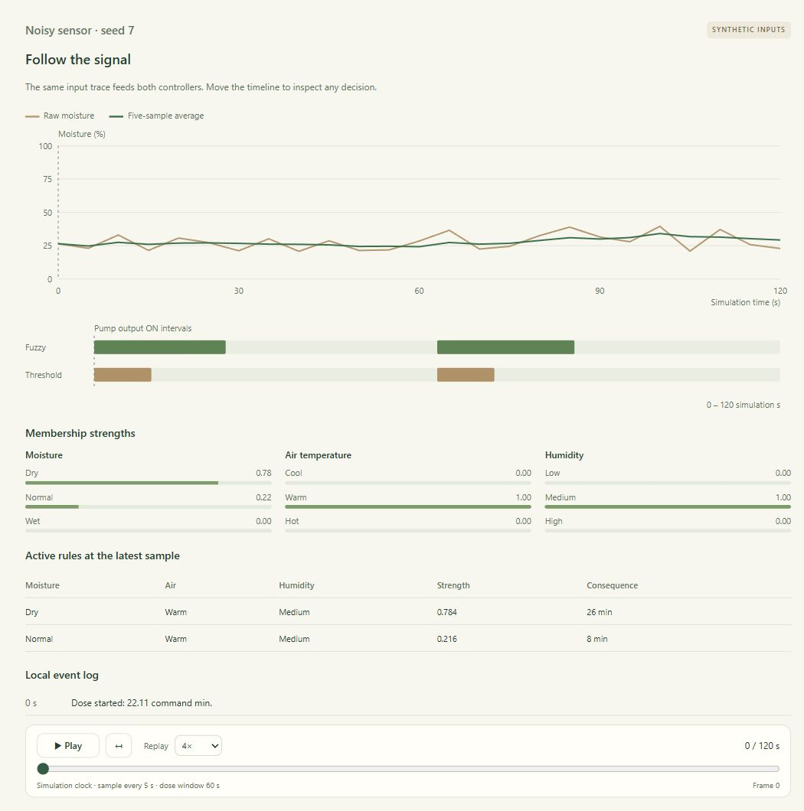
Seed-7 moisture noise and the five-sample average are plotted against the same simulation clock, with separate fuzzy and reference pump intervals.
Replay context: 0 / 120 s. Saved run: 20261024T190247956135Z-4d6f6805. Raw trace and settings accompany the paper.

S-B09 Browser simulation evidence
Separate Python/browser experiment with synthetic inputs and accelerated timers.
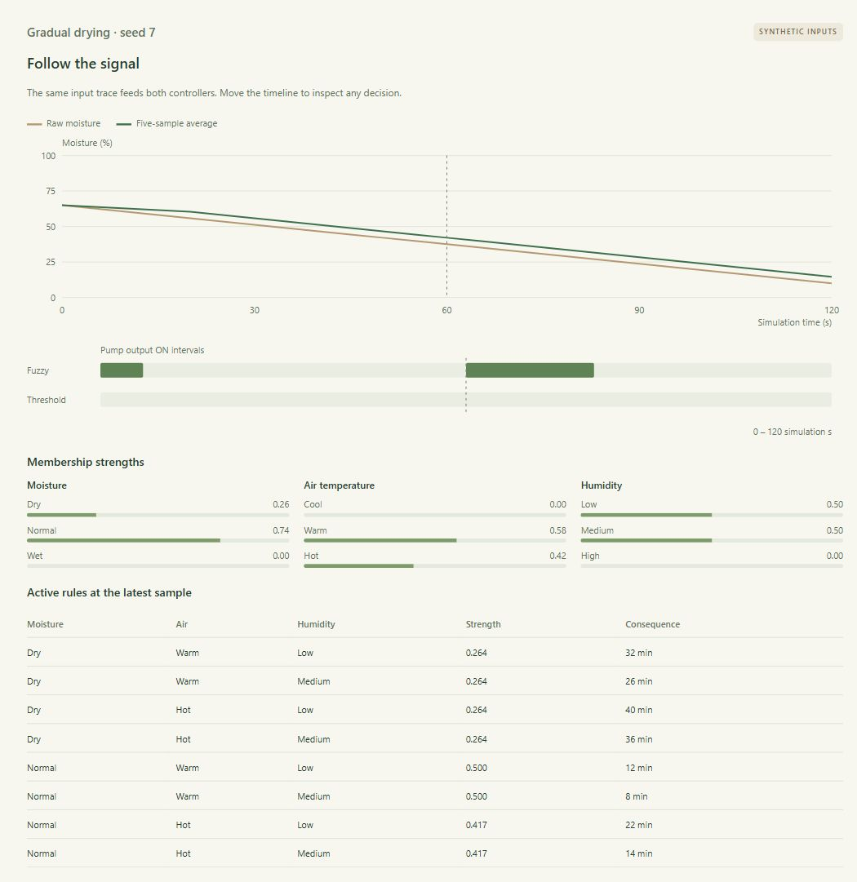
A prescribed moisture ramp from 65% to 10% drives both controllers; the plotted moisture is not affected by pump output.
Replay context: 60 / 120 s. Saved run: 20261024T190251842011Z-b53cba5d. Raw trace and settings accompany the paper.

S-B10 Browser simulation evidence
Separate Python/browser experiment with synthetic inputs and accelerated timers.
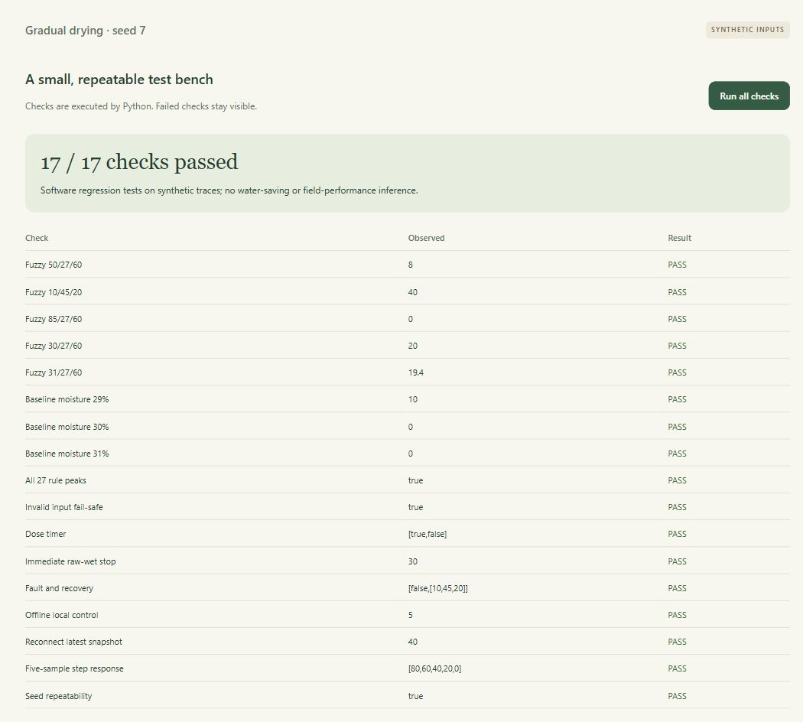
The Python test bench reports 17 of 17 executed checks passed, covering selected commands, rule peaks, boundaries, timer, filtering, faults and transport-surrogate behaviour.
Software regression bench: 17/17 checks passed. The screenshot shows executed checks; it is not a field-trial accuracy test.

S-B11 Browser simulation evidence
Separate Python/browser experiment with synthetic inputs and accelerated timers.
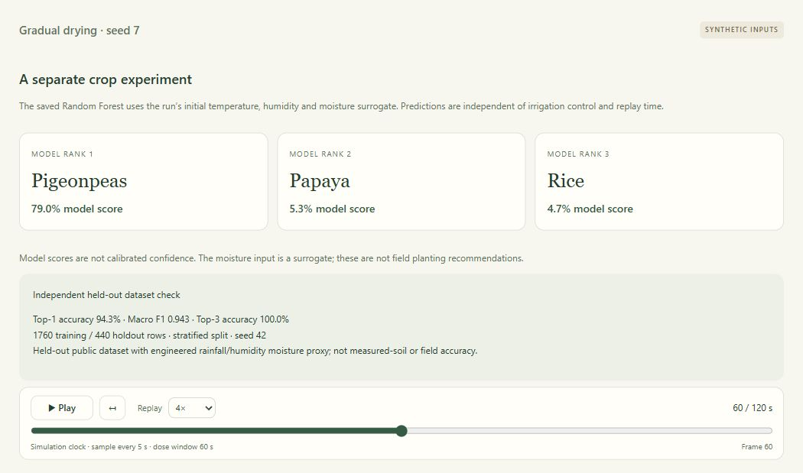
The separate crop experiment reports held-out dataset metrics from 1,760 training and 440 test records; this does not validate physical soil-moisture inputs.
Replay context: 60 / 120 s. Saved run: 20261024T190251842011Z-b53cba5d. Input conditions are listed in Table 6; the crop view uses initial inputs independently of replay.

S-P01 Physical prototype assembly
DHT11 and capacitive-probe breadboard assembly. This assembly did not supply the reported experimental results.
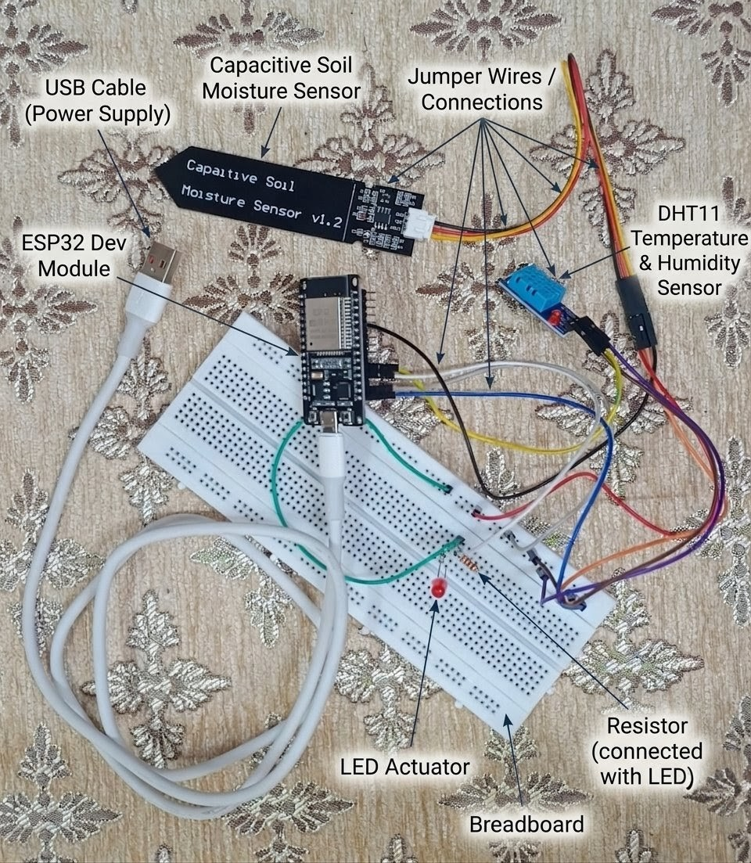
Project photograph retained for provenance. All reported operational results use the browser or Wokwi simulations.

